PROJECT HANDOFF

Instagram Analytics Platform
MVP discovery, validated API spike, architecture decisions, and UX direction
Handoff date: 15 Sep 2026
Source-of-truth rule: Work should treat the decisions and validated API behavior in this document as the current baseline. Re-open decisions only when a new constraint or test result requires it.

Current phase | Discovery complete → move to planning
Next phase | Create GitHub epics/issues, implementation plan, then build MVP
Product name | TBD. “ReachLens” was suggested but not finalized.
MVP user scope | Single app user + one connected Instagram account for development
Target product scope | Multi-user SaaS; each application user can connect N Instagram accounts

1. Product vision
Goal. Build a web application where creators or businesses connect Instagram Professional accounts. The system imports media and insights, stores historical time-series snapshots, closely monitors newly published posts/reels, and turns that data into actionable performance analysis.
- Primary differentiator: time-series monitoring of a new post/reel, not only a static “current totals” dashboard.
- The product must support historical analysis, growth velocity, benchmarks against prior content, and later recommendations/alerts.
- The architecture should support many users and many connected Instagram accounts, even though the first MVP is developed against one real account.

2. Decisions already made
Area | Decision | Status
Frontend | Next.js | Locked for MVP
Backend | ASP.NET Core Web API | Locked for MVP
Database | Microsoft SQL Server + EF Core | Locked for MVP
Auth | ASP.NET Core Identity; secure browser cookie/session preferred | Locked direction
Background jobs | Hangfire; SQL Server storage is sufficient for MVP | Preferred
Instagram integration | Instagram API with Instagram Login | Validated
Instagram permissions | instagram_business_basic + instagram_business_manage_insights | Validated
Deployment | TBD during planning | Open
Important: Facebook Login is intentionally not the MVP path. Instagram Login avoids forcing users to link their Instagram Professional account to a Facebook Page, reducing onboarding friction.

3. Multi-user model
The MVP UI can behave as a single-user product, but the domain and database must be tenant-aware from day one:
ApplicationUser 1 ─── N InstagramAccount
InstagramAccount 1 ─── N InstagramMedia
InstagramMedia 1 ─── N MediaInsightSnapshot
InstagramAccount 1 ─── N AccountInsightSnapshot
Tenant isolation is mandatory. Every read/write operation for InstagramAccount, Media, Snapshots, Monitoring Jobs and future Alerts must be scoped to the authenticated application user. IDs supplied by the browser must never be trusted without ownership checks.

4. UX direction (concept design)
This is the visual UX direction created during discovery. It is conceptual, not a final pixel-perfect specification. Next.js will be used for implementation.
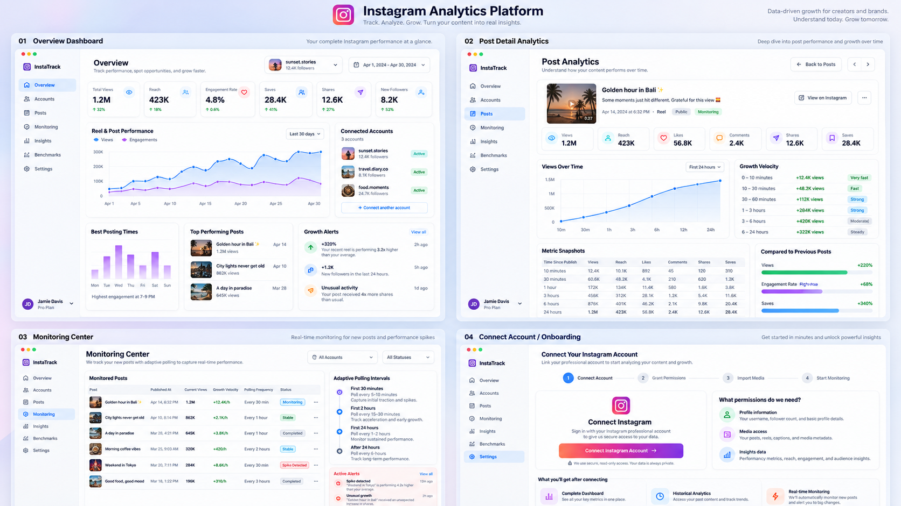
Overview Dashboard · Post Detail Analytics · Monitoring Center · Connect Account / Onboarding

5. MVP UX scope
Screen | Purpose
Connect / Onboarding | Connect Instagram Professional account, explain permissions, import media, start monitoring.
Overview | Account-level KPIs, recent performance, connected accounts, top posts and later posting-time/benchmark widgets.
Posts | Media list with filters and current metrics.
Post Detail | Time-series charts, current insights, snapshot table, velocity and benchmark comparisons.
Monitoring Center | New/active media being polled, latest values, polling status and later alerts.
Out of MVP for now: publishing content, comment management, messaging/DMs, ad analytics, hashtag search, AI recommendations, predictive models, complex alerting and public multi-user onboarding. These can be phased later.

6. Meta / Instagram developer setup completed
- Login requirement discovered: log into developers.facebook.com with the Facebook account first, then register that account as a developer at https://developers.facebook.com/async/registration, then use https://developers.facebook.com/apps/.
- Meta app created and connected to Business Portfolio: Masium.
- Use case selected: “Manage messaging & content on Instagram”.
- Instagram API configured with “API setup with Instagram login”.
- Permissions added and ready for testing: instagram_business_basic and instagram_business_manage_insights.
- Instagram Tester role assigned to masoudkiani.music and invitation accepted.
- Test access token generated successfully.
- Official Meta Postman collection imported and used for API spike.
Public launch later: When the app serves Instagram Professional accounts not owned/managed by the developer, Meta Advanced Access / App Review and related business verification requirements must be planned.

7. Postman environment used for the spike
api_version = v26.0
user_access_token = <manual test token from Meta>
ig_user_id = 17841406595344461
ig_media_id = 17951400225037697 # selected Reel for validation
Security note: Never store or share the actual access token in Git, source code, screenshots or frontend code. In the application it stays server-side and encrypted at rest.

8. API spike — validated endpoints
Test | Endpoint / behavior | Result
Account insights | GET /{ig_user_id}/insights | Successful
Media list | GET /{ig_user_id}/media | Successful + cursor pagination
Media details | GET /{ig_media_id}?fields=... | Successful
Media insights | GET /{ig_media_id}/insights | Successful
Reel watch metrics | avg watch time, total watch time, skip rate | Successful

8.1 Account Insights sample
The account-level reach request returned daily values, confirming account snapshot collection works:
Metric | Period end (UTC) | Value
Reach | 2026-09-14 07:00 | 1,190,187
Reach | 2026-09-15 07:00 | 75,619
Not yet fully validated: the full set of account-level metrics required by the future dashboard. Reach is confirmed; other account metrics should be tested individually during planning/implementation.

8.2 Media list and pagination
GET /{ig_user_id}/media returned media IDs and a cursor-based next URL. This confirms historical import can iterate through all available media using pagination.

8.3 Validated Reel details
Instagram media ID | 17951400225037697
Media type | VIDEO
Product type | REELS
Published (UTC) | 2026-09-13 16:44:52
Permalink | https://www.instagram.com/reel/DdPBKJUMv0r/
Content | “Atre Geroon – Live Version” release Reel

8.4 Validated Reel insights
Metric | Value | API period
Views | 2,297,330 | lifetime
Reach | 1,916,356 | lifetime
Likes | 84,021 | lifetime
Comments | 1,869 | lifetime
Saves | 23,700 | lifetime
Shares | 51,384 | lifetime
Total interactions | 164,539 | lifetime
Total video watch time | 16,131,219,445 ms (~4,480.9 h) | lifetime
Average watch time | 8,667 ms (8.667 s) | lifetime
3-second skip rate | 51.5% | lifetime
Key product implication. Media insight values are lifetime/current totals, so the product creates the time series by repeatedly collecting snapshots. This is exactly the data model needed for view velocity, share velocity, save velocity, acceleration and growth curves.

8.5 Unsupported / unreliable media-level metrics
Metric | Observed API behavior | MVP decision
reposts | Media Insights endpoint rejected it for this Reel | Do not depend on it
follows | Not supported for this media product type | No direct Reel attribution
profile_visits | Not supported for this media product type | No direct Reel attribution
profile_activity | Not supported for this media product type | No direct Reel attribution
Interpretation: Follower/profile changes may be measured at account level during the Reel’s growth window, but that is correlation, not guaranteed attribution to one Reel.

8.6 Data freshness observation
During the spike, closely spaced endpoints did not always expose identical counts at the same moment (for example media detail vs media insights). This suggests asynchronous metric refresh. For time-series calculations, use a consistent insight endpoint and timestamp every snapshot; do not mix counters from different endpoint types in one series.

9. Core data model for MVP planning
ApplicationUser
└── InstagramAccount
├── InstagramCredential (encrypted token + expiry/refresh metadata)
├── InstagramMedia
│ ├── MediaCurrentStats
│ └── MediaInsightSnapshot [append-only time series]
├── AccountCurrentStats
└── AccountInsightSnapshot [append-only time series]
MonitoringJob / MonitoringState references InstagramMedia
- InstagramMedia stores relatively stable metadata: InstagramMediaId, caption, media_type, media_product_type, permalink, timestamp, thumbnail URL.
- MediaCurrentStats stores the latest values for fast dashboard reads.
- MediaInsightSnapshot is append-only and is the source for charts, velocity and historical comparisons.
- Raw API JSON should be retained where practical so future Meta metric changes do not destroy useful historical context.

10. Monitoring model
The system must detect newly published media and collect snapshots more frequently while the content is fresh, then reduce polling as it ages. The exact cadence is not yet locked because API refresh cadence and rate limits still need to be measured.
Candidate adaptive schedule for planning discussion (not yet validated):
0–30 min every 2–5 min
30–120 min every 5–10 min
2–6 hours every 10–20 min
6–24 hours every 30–60 min
1–7 days every 2–6 hours
after 7 days daily / on-demand
Required validation before locking this: repeat the same Reel insight request at short intervals and observe actual Meta data refresh frequency; review current API rate-limit headers/limits.

11. Derived analytics planned from snapshots
views_delta = current.views - previous.views
views_per_minute = views_delta / elapsed_minutes
shares_delta = current.shares - previous.shares
share_rate = shares / views
save_rate = saves / views
like_rate = likes / views
reach_rate = reach / views
velocity_change = current_velocity - previous_velocity
Later benchmark logic can compare a new Reel at the same age (e.g., 30m / 1h / 3h / 6h / 24h) against prior Reels, percentiles and similar content. This is not required for the first technical vertical slice but should influence snapshot/query design.

12. Authentication and security baseline
- Application authentication: ASP.NET Core Identity.
- For the browser app, prefer Secure + HttpOnly cookie/session authentication rather than exposing auth tokens to JavaScript/localStorage.
- Instagram OAuth/access tokens live only in ASP.NET Core, encrypted at rest; never return them to Next.js.
- All APIs enforce per-user ownership/tenant isolation for connected Instagram accounts and their media.
- Use HTTPS, CSRF protection for cookie-authenticated state-changing requests, rate limiting, login lockout and security logging.

13. MVP acceptance goal
The MVP is successful when this vertical flow works reliably end to end:
User signs in
→ Connects Instagram Professional account
→ System imports historical media
→ Current insights are stored
→ A newly published Reel is detected
→ Insights are snapshotted over time
→ Post Detail shows the growth curve and snapshot history
→ Monitoring Center shows polling state/current velocity
Do not expand scope into AI recommendations or large benchmark features until this loop is stable.

14. Open decisions for the Work planning phase
- Finalize product name and repository name.
- Define repo structure (monorepo vs separate frontend/backend) and environments.
- Finalize SQL Server schema, indexes, retention strategy and RawJson policy.
- Design Instagram OAuth callback/token refresh/reconnect lifecycle for real users.
- Determine how new media is detected (polling and/or webhook capabilities relevant to this flow).
- Validate Meta rate limits and actual insight refresh frequency, then lock adaptive polling cadence.
- Define exact account-level metrics to persist and validate them in Postman.
- Define Next.js route/component structure matching the approved UX direction.
- Plan deployment, secrets/key management and observability.
- Plan Meta App Review / Advanced Access requirements for public multi-user onboarding.

15. Required next action in Work
Use this handoff as the source of truth. Do not start coding immediately. First produce the MVP implementation plan, define GitHub Epic(s), break them into ordered Issues/Tasks with acceptance criteria and dependencies, and identify any remaining API/architecture spikes. After review/approval, begin implementation issue by issue.

16. Suggested planning sequence
Order | Planning output
1 | MVP scope and explicit non-goals
2 | Architecture + repo structure
3 | Database/domain model
4 | Instagram OAuth/integration lifecycle
5 | Monitoring/polling design
6 | API contracts between Next.js and ASP.NET Core
7 | UX routes/components mapped to the concept
8 | GitHub Epics → Issues/Tasks with acceptance criteria
9 | Implementation sequence and release milestones

Appendix A — Useful Postman requests
GET https://graph.instagram.com/{{api_version}}/{{ig_user_id}}/media
GET https://graph.instagram.com/{{api_version}}/{{ig_media_id}}?fields=id,caption,media_type,media_product_type,permalink,timestamp,thumbnail_url,like_count,comments_count
GET https://graph.instagram.com/{{api_version}}/{{ig_media_id}}/insights?metric=views,reach,likes,comments,saved,shares,total_interactions
GET https://graph.instagram.com/{{api_version}}/{{ig_media_id}}/insights?metric=ig_reels_video_view_total_time,ig_reels_avg_watch_time,reels_skip_rate
GET https://graph.instagram.com/{{api_version}}/{{ig_user_id}}/insights?metric=reach,profile_views&period=day

Appendix B — Files to carry into Work
- This handoff document (source of truth).
- Official Meta Postman collection used during the spike: Instagram API.postman_collection.json.
- UX concept image is embedded in this document; the original PNG can also be attached if needed for visual work.

